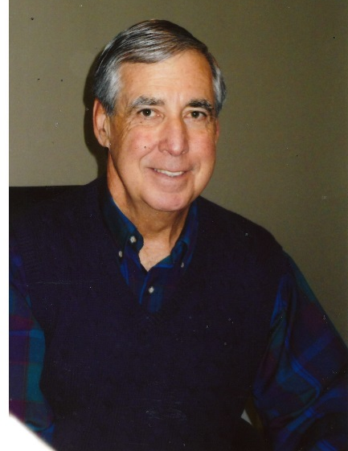

MIKE GOIN
- Graduate of Astoria High School in 1967 where he participated in cross country, basketball and track
- Pacific Lutheran University with a B.S. in Business Education
- Astoria High School teacher and coach from 1975-2002
- Head boys basketball coach from 1978-2002. State 3A Champions in 1998
- Athletic Director from 1985-2002
- OADA Executive Board 3A Representative 8 years
- OADA 3A Athletic Director of the Year in 2002
- Astoria High School Hall of Fame Inductee in 2010

